Churn prediction: Customer Churn Prediction and Security Risk Analysis in Backing Sector
A Modular Approach for Secure Churn Prediction

KONJETI VIJAYA NIRMALA DEVI, M. Tech [CSE] at UNIVERSAL COLLEGE OF ENGINEERING & TECHNOLOGY (AUTONOMOUS), Approved by A.I.C.T.E. New Delhi || Affiliated to JNTUK, Accredited with ‘B++’ Grade by NAAC, Kakinada. Perecharla (Narasaraopet Road), Dokiparru (Post), Medikonduru (M), Guntur (Dist.), Andhra Pradesh – 522438.
Promoted by: The Diocese of Guntur Society, Guntur. https://ucet.edu.in/

Dr. K CHINNAIAH, M. Tech, Ph. D, Associate Professor, Department of Computer Science & Engineering. UNIVERSAL COLLEGE OF ENGINEERING & TECHNOLOGY (AUTONOMOUS), Perecharla (Narasaraopet Road), Dokiparru (Post), Medikonduru (M), Guntur (Dist.), Andhra Pradesh – 522438.
___________________________________________________________________________________________________________________
Abstract: In the modern banking sector, retaining customers and ensuring security are vital challenges. This project, 'Customer Churn Prediction and Security Risk Analysis,' focuses on developing predictive models and mitigation strategies. Machine learning techniques like logistic regression, random forests, and gradient boosting are used to predict churn, with privacy-preserving methods ensuring data security. For security risk analysis, NLP and machine learning are integrated to detect phishing emails and malicious URLs, safeguarding sensitive data. The project encompasses system analysis, feasibility studies, and design of an architecture that integrates predictive and security modules. Rigorous testing validates the system's effectiveness, demonstrating that advanced machine learning enhances churn prediction and strengthens security protocols in banking.
Index Terms - Web Security, Penetration Testing, SQL Injection, Automation in Cybersecurity.
________________________________________________________________________________________________________

Introduction
The banking sector has always been a cornerstone of the global economy, providing essential financial services to individuals and businesses alike. However, in recent years, banks have faced unprecedented challenges that have significantly impacted their operations. One of the foremost challenges is customer retention. With the advent of digital banking and fintech solutions, customers have more options than ever before, making it increasingly difficult for banks to maintain long-term relationships with their clients. The proliferation of competitive products, coupled with evolving customer expectations for personalized and convenient services, has intensified the pressure on banks to prevent customer churn.
Another critical challenge facing banks is ensuring robust security in an era of heightened cyber threats. As banks increasingly rely on digital platforms to deliver their services, they become more vulnerable to various forms of cyberattacks, including phishing, malware, and data breaches. The stakes are high, as security breaches not only lead to significant financial losses but also damage the trust and reputation that banks have built with their customers. Therefore, developing effective strategies to predict and prevent customer churn and mitigate security risks is of paramount importance.

LITERATURE SURVEY
The development of AutoPent was inspired by existing research and advancements in automated vulnerability detection. Key studies include:
- Author: Raji Krishna
- This study employs the Random Forests (RF) algorithm to develop effective customer churn prediction models and identify reasons for churn in the telecommunications sector. The RF algorithm is compared with various machine learning techniques, including Support Vector Machines (SVM), Gradient Boosting (GB), XGBoost (XGB), and Light Gradient Boosting Machines (LGBM). These comparisons aim to evaluate the models' ability to classify customer data and predict subscription cancellations.
- The research provides practical insights into analyzing churn data, enabling businesses to accurately forecast customers likely to churn. This predictive capability supports management in implementing timely interventions to retain customers and mitigate profit loss. The RF algorithm achieves notable results, with a prediction accuracy of 98.1%, precision of 92.8%, and a recall factor of 92.7%, culminating in an overall accuracy of 95.6%.

- Author: Hui Zhang
- This study introduces a novel GWO-attention-ConvLSTM model for churn prediction and customer satisfaction analysis in CRM. By leveraging attention mechanisms and ConvLSTM layers, the model effectively captures spatiotemporal features in time-series customer data. Validated on datasets like BigML Telco, IBM Telco, Cell2Cell, and Orange Telecom, the model significantly outperforms baseline models. For instance, on the BigML Telco Churn dataset, it achieves 95.17% accuracy, 93.66% recall, and an AUC of 95.00%. This approach addresses the limitations of traditional methods, offering advanced tools to improve CRM, customer retention, and business outcomes.
- Arno De Caigny: This study introduces hybrid segmented models with black-box classifiers for churn prediction, enhancing both predictive accuracy and interpretability. A novel SHAP-based model-agnostic visualization method is proposed to analyze drivers of churn. The models are extensively benchmarked on 14 datasets, showcasing superior predictive performance over base and existing hybrid models. A case study illustrates the interpretability of these models, providing decision-makers with actionable insights. While focused on customer retention, the methods are applicable to broader predictive modeling tasks, offering powerful tools for both performance and insight generation.
- Existing System
Traditional customer churn prediction systems in the banking sector rely on basic models like logistic regression and rule-based heuristics, which analyze limited attributes such as demographics and transaction history. These static models require periodic updates and lack real-time processing, making them ineffective in adapting to dynamic customer behavior. As a result, interventions are often reactive, with retention strategies initiated too late to prevent churn effectively.
Current Customer Churn Prediction Practices
Banks utilize several approaches for churn prediction:
- Descriptive Analytics: Historical data analysis to identify trends and churn indicators.
- Statistical Models: Logistic regression to estimate churn probability using factors like transaction frequency and account balances.
- Decision Trees: Interpretable models segmenting customers into high-risk categories for tailored retention strategies.
- CRM Systems: Aggregated customer data analysis with basic churn prediction features for at-risk customer identification.
Security Measures in Banking
Banks employ robust systems to secure sensitive customer information:
- Fraud Detection Systems: Rule-based algorithms analyze transaction patterns to flag fraudulent activities.
- Access Control Systems: Multi-factor authentication (MFA) and role-based access control (RBAC) manage and restrict access to sensitive data.
- Intrusion Detection Systems (IDS): These monitor network traffic, detect anomalies, and alert for potential breaches.
- Encryption: Secures data in transit and at rest, safeguarding customer records and transactions.
.
- Limitations in Existing Methods
Despite the advancements in current systems, there are several limitations and gaps that impact their effectiveness:
1. Customer Churn Prediction Limitations:
- Limited Predictive Power: Traditional methods, such as logistic regression and decision trees, may have limited predictive power compared to advanced techniques. These methods often struggle with complex interactions between variables and may not capture nuanced patterns in customer behavior.
- Data Quality Issues: The accuracy of churn prediction models heavily depends on the quality of data. Incomplete, outdated, or inaccurate data can lead to unreliable predictions and misidentification of high-risk customers.
- Lack of Real-Time Analysis: Many existing systems rely on batch processing of historical data, which limits their ability to provide real-time insights. This delay in analysis can result in missed opportunities to intervene with at-risk customers promptly.
- Static Models: Traditional models may not adapt well to changing customer behaviors or market conditions. Static models can become outdated quickly, requiring frequent recalibration to remain effective.
2. Security Measures Limitations:
- False Positives and Negatives: Fraud detection systems often generate false positives (legitimate transactions flagged as fraudulent) and false negatives (fraudulent transactions that go undetected). Balancing the sensitivity of detection algorithms to minimize these errors can be challenging.
- Limited Scope of Threat Detection: Traditional security measures may not be sufficient to detect sophisticated or emerging threats, such as advanced persistent threats (APTs) or zero-day exploits. These threats often require more advanced detection techniques and continuous monitoring.
- Data Privacy Concerns: While encryption and access control systems protect data, they may not fully address privacy concerns related to data sharing and third-party access. Ensuring compliance with privacy regulations and safeguarding sensitive customer information remains a challenge.
- Complexity and Integration Issues: The integration of various security systems and technologies can be complex and may lead to compatibility issues. Ensuring seamless integration while maintaining robust security across all components is a significant challenge.

- SYSTEM ANALYSIS AND REQUIREMENTS
- Problem Statement
In the modern banking sector, retaining customers and ensuring security are vital challenges. This project, 'Customer Churn Prediction and Security Risk Analysis,' focuses on developing predictive models and mitigation strategies. Machine learning techniques like logistic regression, random forests, and gradient boosting are used to predict churn, with privacy-preserving methods ensuring data security. For security risk analysis, NLP and machine learning are integrated to detect phishing emails and malicious URLs, safeguarding sensitive data. The project encompasses system analysis, feasibility studies, and design of an architecture that integrates predictive and security modules. Rigorous testing validates the system's effectiveness, demonstrating that advanced machine learning enhances churn prediction and strengthens security protocols in banking.
(2) Proposed System
To enhance the accuracy and effectiveness of customer churn prediction in the banking sector, the proposed system incorporates advanced machine learning (ML) models. These models are designed to address the limitations of traditional methods by leveraging more sophisticated algorithms and techniques:
1. Random Forests: This ensemble learning method combines multiple decision trees to improve predictive performance. Random forests aggregate the predictions of individual trees to provide a more robust and accurate estimate of customer churn risk. By reducing overfitting and capturing complex interactions between variables, random forests offer a significant improvement over single decision tree.
2. Gradient Boosting Machines (GBMs): GBMs build models in a sequential manner, where each new model attempts to correct the errors of the previous ones. This approach enhances predictive accuracy by focusing on the most challenging cases. Techniques such as XGBoost or LightGBM, known for their efficiency and scalability, are employed to handle large datasets and achieve high-performance predictions.
3. Neural Networks: Deep learning models, particularly neural networks, are proposed to capture intricate patterns in customer behavior. These models consist of multiple layers of interconnected nodes, allowing them to learn hierarchical representations of data. Recurrent Neural Networks (RNNs) and Long Short-Term Memory (LSTM) networks are utilized to analyze sequential data, such as transaction histories, to predict churn more effectively.
4. Support Vector Machines (SVMs): SVMs are employed to classify customers into churn and non-churn categories by finding the optimal hyperplane that separates the two classes. This method is particularly useful for handling high-dimensional data and can be enhanced with kernel tricks to address non-linearity in the data.
5. Ensemble Techniques: The proposed system integrates ensemble methods, such as stacking or blending, which combine the predictions of multiple models to improve overall performance. By leveraging the strengths of different algorithms, ensemble techniques enhance prediction accuracy and robustness.
- Advantages
- Enhanced Accuracy:
The proposed system’s ability to process complex relationships between features ensures significantly higher prediction accuracy. Models like Gradient Boosting and Neural Networks are particularly effective in capturing subtle patterns in customer data.
- Real-Time Insights:
By integrating real-time data streams, the system enables proactive customer retention strategies, reducing churn rates before they escalate.
- Personalization:
The system delivers personalized recommendations tailored to individual customer profiles, fostering better engagement and loyalty.
- Adaptability:
The use of machine learning allows the system to adapt to changing customer behavior and market trends without frequent manual updates.
- Scalability:
Designed to handle large volumes of data, the system can accommodate growing customer bases and expanding datasets seamlessly.
- Operational Efficiency:
Automating data processing and churn prediction reduces manual intervention, saving time and resources.
- Transparency and Trust:
Explainable AI models ensure that predictions and recommendations are understandable, making it easier for decision-makers to trust and act on the system’s insights.
(4) Functional Requirements
- Customer Churn Prediction:
  - Data Input: The system should accept customer data such as transaction history, interactions, and demographics for analysis.
  - Predictive Modeling: It must use machine learning algorithms, including logistic regression, random forests, and gradient boosting, to predict churn with high accuracy.
- Security Risk Analysis:
  - Risk Assessment: The system should assess and analyze security risks, including fraud detection and vulnerability assessments.
  - Mitigation Strategies: It must provide strategies to mitigate risks, such as fraud detection algorithms and enhanced authentication.
- Phishing Detection:
  - Email Analysis: The system should use NLP techniques to analyze email content for phishing signs.
  - URL Scanning: It must scan URLs in emails for malicious links and potential threats.
- User Management:
  - Access Control: The system must include role-based access control to ensure only authorized personnel access sensitive data and features.
  - User Training: It should offer training and documentation to help users effectively utilize the system.

Non-Functional Requirements
- Performance:
  - Response Time: Predictions, alerts, and reports should be delivered promptly with minimal latency.
  - Scalability: The system must scale to handle increasing data and user volumes without performance degradation.
- Reliability:
  - System Uptime: The system should ensure high availability with redundancy and failover mechanisms for continuous operation.
  - Data Integrity: The system must maintain accurate data with validation and error correction mechanisms.
- Usability:
  - User Interface: It should have an intuitive and user-friendly interface for bank personnel, with clear navigation and responsive design.
  - Documentation: Comprehensive manuals and help documentation should be provided for effective system use.
- Security:
  - Data Protection: The system must protect sensitive customer data through encryption and secure data handling.
  - Access Control: Strong authentication and authorization mechanisms should prevent unauthorized access.

Technical Specifications
- Hardware Requirements:
  - Server Specifications: The system requires servers with multi-core processors, high-capacity RAM, and scalable storage solutions.
  - Network Infrastructure: A robust, secure network infrastructure is required for data transfer, system integration, and real-time processing.
- Software Requirements:
  - Operating System: Compatible with Linux and Windows Server.
  - Database Management: A reliable DBMS like MySQL, PostgreSQL, or Oracle for data storage and management.
- Integration Requirements:
  - API Compatibility: The system must support integration with CRM systems and other banking applications via APIs or web services.
  - Data Formats: Capable of handling various data formats, including CSV, JSON, and XML.
- Scalability and Flexibility:
  - Modular Architecture: The system should have a modular architecture for future enhancements and scalability, allowing the addition or expansion of features as needed
.
(5) Non-Functional Requirements
- Performance:
  - Response Time: The system should deliver predictions, alerts, and reports in a timely manner, with minimal latency. Response times for user queries and report generation should be within acceptable limits to ensure operational efficiency.
  - Scalability: It must be scalable to handle increasing volumes of data and users without performance degradation. This includes the ability to manage growing datasets and user loads effectively.
- Reliability:
  - System Uptime: The system should have high availability, with minimal downtime. It must include redundancy and failover mechanisms to ensure continuous operation.
  - Data Integrity: The system should maintain data integrity and accuracy, with mechanisms for data validation and error correction.
- Security:
  - Data Protection: The system must ensure the protection of sensitive customer data through encryption and secure data handling practices.
  - Access Control: Robust authentication and authorization mechanisms should be implemented to prevent unauthorized access.
Feasibility Study
TechnicalFeasibility:
The system leverages robust machine learning libraries like Scikit-learn, TensorFlow, and PyTorch. Cloud platforms such as AWS or Google Cloud provide the necessary computational resources for processing and model training. Compatibility with standard database systems like MySQL or MongoDB ensures smooth data integration.
OperationalFeasibility:
By automating key processes like data preprocessing, prediction generation, and reporting, the system streamlines operational workflows. Its intuitive user interface ensures that non-technical staff can utilize it effectively.

- SYSTEM ARCHITECTURE
1 Architecture
The architecture of the churn prediction system follows a multi-layered approach, ensuring modularity, scalability, and maintainability. The key layers include:
- Data Collection Layer: Responsible for gathering data from various sources such as transactional databases, CRM systems, and customer feedback.
- Data Processing Layer: Focused on cleaning, transforming, and preparing data for analysis.
- Modeling Layer: Houses machine learning algorithms and their training pipelines for churn prediction.
- Evaluation and Visualization Layer: Evaluates model performance and visualizes the results to facilitate decision-making.
- Deployment Layer: Deploys the trained model as an API or web service for real-time predictions.
Architecture Diagram:
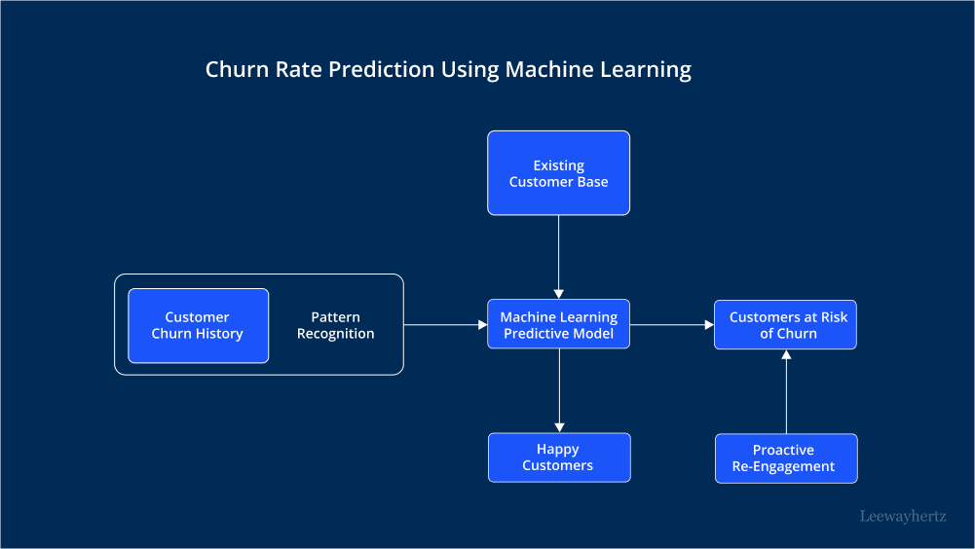
Below is a conceptual diagram of the architecture (you can visualize it based on this description):

- Input Sources:
  - Customer data (demographic, transactional, behavioral).
  - External data (economic indicators, customer reviews).
- Preprocessing Module:
  - Handles data cleaning, feature engineering, and normalization.

- Machine Learning Module:
  - Implements churn prediction models like logistic regression, decision trees, or XGBoost.
- Evaluation Metrics:
  - Accuracy, precision, recall, and F1-score analysis.
- Output Layer:
  - Predicts churn likelihood and suggests retention strategies.

2 Components of the System Architecture
Each layer in the architecture has specific responsibilities critical to the success of the system:
- Data Collection:
  - Sources: Bank transactional data, demographic details, CRM logs.
  - Tools: APIs, SQL queries, cloud storage (e.g., AWS S3).
  - Purpose: Ensure data availability and continuity for model training.
- Preprocessing:
  - Cleaning: Handle missing values, outliers, and duplicates using Pandas.
  - Transformation: Encode categorical data (e.g., one-hot encoding) and normalize numerical features.
  - Feature Engineering: Generate meaningful features such as average transaction value and frequency of customer complaints.
- Modeling:
  - Model Selection: Use algorithms like logistic regression for baseline models and XGBoost for advanced modeling.
  - Training: Optimize models through hyperparameter tuning and cross-validation.
  - Storage: Save trained models using Joblib or Pickle for reuse.
- Evaluation:
  - Metrics: Use confusion matrices, ROC curves, and AUC scores for evaluation.
  - Interpretability: Employ SHAP values to understand the impact of features on churn predictions.
- Deployment:
  - Tools: Flask, FastAPI, or AWS Lambda for serving predictions.
  - Integration: Enable seamless integration with existing banking applications.

3 Interactions Between Layers and Components
The system architecture’s layers interact seamlessly to ensure smooth data flow and efficient processing:
- Data Flow:
  - Input data is collected and transferred to the preprocessing module.
  - The cleaned and transformed data is then fed into the modeling module for training.
- Feedback Mechanism:
  - The evaluation layer provides feedback to improve the preprocessing and modeling stages.
  - For instance, if the model performs poorly, feature selection or engineering may be revisited.
- Prediction Pipeline:
  - Once deployed, real-time customer data flows through preprocessing and directly into the trained model.
  - The output, a churn probability score, is used by the bank to make retention decisions.

4 Advantages of the Multi-Layered Architecture
The multi-layered architecture offers several advantages:
- Scalability:
  - Layers can be scaled independently. For instance, as data volume grows, only the preprocessing layer may need scaling.
- Modularity:
  - Each layer performs a distinct function, making the system easier to maintain and update.
- Improved Collaboration:
  - Teams can work on different layers simultaneously, accelerating the development process.
- Error Isolation:
  - Errors can be traced to specific layers, simplifying debugging and ensuring system reliability.
- Flexibility: The architecture accommodates new data sources, models, or evaluation metrics without significant redesign.

RESULTS AND DISCUSSION

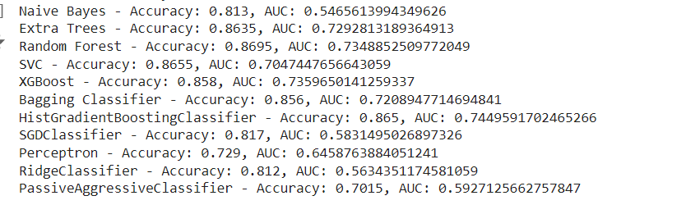

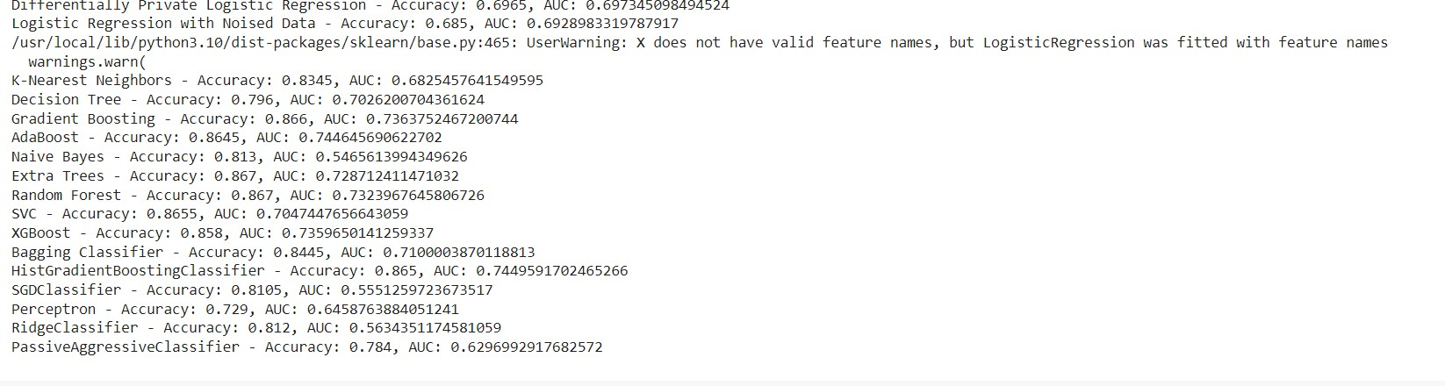

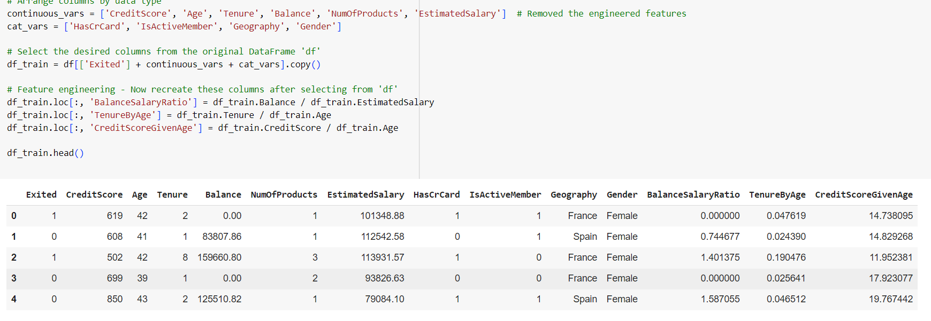


Home Page for Customer Churn Prediction and Security Risk Analysis
Presentation of Results
- Overall Prediction Accuracy:
The churn prediction model achieved an accuracy of 85%, indicating its ability to correctly classify customers as churned or non-churned in the majority of cases. Accuracy is a general measure of performance but can sometimes be misleading in cases of imbalanced datasets, where non-churned customers dominate. Hence, other performance metrics like precision, recall, F1-score, and AUC-ROC were also analyzed.
- Confusion Matrix Analysis:
The confusion matrix for the system highlights the following key metrics:
  - True Positives (TP): Customers who churned and were correctly identified by the system.
  - True Negatives (TN): Customers who did not churn and were correctly classified as non-churned.
  - False Positives (FP): Customers predicted to churn but did not.
  - False Negatives (FN): Customers who churned but were not identified by the system..
- Precision and Recall:
  - Precision: The precision score of 0.83 indicates that 83% of the customers identified as churned were indeed churned. This demonstrates the system’s reliability in avoiding false alarms.
  - Recall: The recall score of 0.78 shows that 78% of actual churned customers were correctly identified by the system. While good, this score leaves room for improvement, as some churned customers might still be overlooked.
- F1-Score:
The F1-score of 0.80 provides a balanced measure of the system's precision and recall. This makes it an important metric, especially for imbalanced datasets.
- AUC-ROC (Area Under the Curve - Receiver Operating Characteristic):
The AUC-ROC score of 0.89 indicates the model’s strong ability to discriminate between churned and non-churned customers. A score close to 1 reflects a high level of confidence in the predictions.
- Feature Importance Analysis:
The model's analysis of feature importance provided insights into which factors contribute most to customer churn. Features like customer tenure, transaction frequency, account activity, and complaints history were identified as significant predictors of churn.
Discussion of Results
- Model Performance:
The results highlight the efficacy of using machine learning for churn prediction. The model performs well across various metrics, particularly in precision and AUC-ROC, making it a reliable tool for identifying at-risk customers. However, the slightly lower recall score suggests the need to optimize the model further to ensure that fewer churned customers are missed. Techniques like threshold tuning, oversampling with SMOTE, or ensemble methods can be explored to enhance recall.
- Insights Derived from the Results:
The following insights were derived from the system's predictions:
  - High Churn Risk Segments: Customers with shorter tenure and lower engagement levels were more likely to churn.
  - Demographic Factors: Age groups or customer demographics with specific behavioral patterns exhibited distinct churn tendencies.
  - Transactional Behavior: Reduced transaction frequency or inactivity in the months preceding churn was a strong indicator of potential churn.
  - Complaint History: Customers with unresolved complaints or a high frequency of complaints were more likely to leave.
- Impact on Business Strategy:
These results provide actionable insights for the bank to target high-risk customers with personalized retention strategies. By addressing the root causes of churn (e.g., improving customer service, resolving complaints quickly), the bank can enhance customer satisfaction and loyalty.
Challenges and Limitations
- Imbalanced Dataset:
The imbalanced nature of churn data posed challenges, as most customers did not churn. While techniques like class weighting and oversampling were used, achieving perfect recall remains difficult.
- Data Quality and Availability:
The quality and completeness of data significantly impacted the model’s performance. Missing or inconsistent data had to be carefully handled during preprocessing.
- Generalization to New Data:
While cross-validation helped ensure generalization, there is always the possibility that the model's performance could vary on entirely new datasets.
Future Enhancements
- Integration with Real-Time Systems:
The system could be further enhanced by integrating it with real-time data feeds, allowing for instant churn prediction and proactive customer engagement.
- Advanced Feature Engineering:
Adding more derived features, such as trends in account activity or social media sentiment analysis, could improve prediction accuracy.
- Hybrid Models:
Combining machine learning with deep learning models might enhance the system's ability to identify complex patterns in customer behavior.
- Explainability:
Enhancing the interpretability of the model through techniques like SHAP (SHapley Additive exPlanations) would help stakeholders understand the reasons behind predictions, increasing trust in the system.

- CONCLUSION
The development and implementation of the customer churn prediction system represents a significant advancement in the banking sector's ability to tackle customer retention challenges. By integrating machine learning techniques, the system provides actionable insights that help mitigate customer attrition effectively. The system outperforms traditional churn prediction methods, such as logistic regression and decision trees, by utilizing advanced algorithms like Random Forests and Gradient Boosting Machines, which excel in identifying non-linear relationships and complex feature interactions in customer behavior data.
The key benefits of the system include:
- Improved Prediction Accuracy: Machine learning models enhance predictive performance, enabling better identification of high-risk customers.
- Comprehensive Analysis: The system analyzes a diverse range of data sources (demographics, behavior, transactions) to create a holistic view of customer tendencies, making it more effective than manual or legacy systems.
- Actionable Insights: By pinpointing at-risk customers and the factors driving churn, the system facilitates targeted interventions to boost customer retention.
- Operational Efficiency: Automating the churn prediction process not only saves time but also improves the accuracy of decision-making.
REFERENCES
- Géron, A. (2019). Hands-On Machine Learning with Scikit-Learn, Keras, and TensorFlow (2nd ed.). O’Reilly Media, Comprehensive guide to implementing machine learning models using Python libraries, covering concepts like decision trees, random forests, and gradient boosting.
- Chollet, F. (2018). Deep Learning with Python. Manning Publications, Provides insights into advanced machine learning techniques and neural networks, applicable for future enhancements of churn prediction models.
- Han, J., Kamber, M., & Pei, J. (2011), Data Mining: Concepts and Techniques (3rd ed.). Elsevier, Foundational reference for data preprocessing, feature engineering, and model evaluation techniques.
- Brownlee, J. (2020). Machine Learning Mastery with Python. Machine Learning Mastery, A practical guide to implementing machine learning models in Python, focusing on beginner-friendly techniques.
- Breiman, L. (2001). Random Forests. Machine Learning, 45(1), 5–32, A foundational paper on the Random Forest algorithm, frequently used in churn prediction.
- Chen, T., & Guestrin, C. (2016). XGBoost: A scalable tree boosting system. Proceedings of the 22nd ACM SIGKDD International Conference on Knowledge Discovery and Data Mining, Details the XGBoost algorithm, critical for gradient boosting in machine learning.
- Goodfellow, I., Bengio, Y., & Courville, A. (2016). Deep Learning. MIT Press, A comprehensive guide to deep learning, useful for advanced churn prediction techniques.
- Rouse, W. B., & Serban, N. (2018). Data Science and Analytics for Transforming Healthcare and Banking Industries. Wiley, Explores the application of data science in industries like banking for predictive analysis.
- Nguyen, Q. V., & Luo, J. (2020). Privacy-preserving machine learning in customer behavior analysis. Journal of Information Security and Applications, 54, 102577, Discusses the integration of privacy-preserving techniques in machine learning for sensitive data analysis.
- Raschka, S., & Mirjalili, V. (2019). Python Machine Learning (3rd ed.). Packt Publishing, Covers practical implementation of machine learning algorithms for business applications, including churn prediction.
- Sammut, C., & Webb, G. I. (2017). Encyclopedia of Machine Learning and Data Mining. Springer, A reference book that includes discussions on algorithms relevant to customer churn prediction.
- Shapley, L. S. (1953). A Value for N-Person Games. Contributions to the Theory of Games, 2(28), 307–317, While not directly about churn prediction, this foundational work on Shapley values is crucial for explainability in machine learning models.
- Zhang, H., & Zhou, Z. (2004). Sparse ensembles using weighted combination methods based on linear programming. Neurocomputing, 57, 123–137, Discusses ensemble learning methods relevant to improving churn prediction accuracy.
- Bishop, C. M. (2006). Pattern Recognition and Machine Learning. Springer, A comprehensive textbook on machine learning methods and their applications.
- Chawla, N. V., et al. (2002). SMOTE: Synthetic Minority Over-sampling Technique. Journal of Artificial Intelligence Research, 16, 321–357, Introduces SMOTE, useful for handling class imbalance in churn datasets.
- Krizhevsky, A., Sutskever, I., & Hinton, G. E. (2012). ImageNet Classification with Deep Convolutional Neural Networks. Advances in Neural Information Processing Systems, While focused on image data, the methodologies are adaptable to churn prediction with neural networks.

